**Analysis of One-Year Kilowatt Hourly Load Shape of A Residential Customer**

**Summary Table**

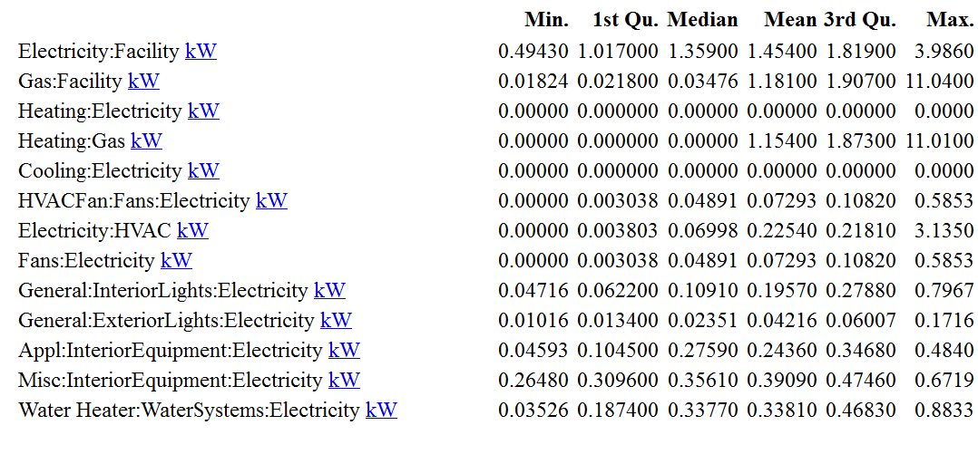

* The maximum and minimum ElectricitY:Facility consumption 3.99 and 0.49 occurs on 08/19 at 17:00 and 06/27 at 03:00 respectively.
* The maximum and minimum Gas:Facility consumption 11.04 and 0.018 occurs on 01/17 at 17:00 and 08/12 at 03:00 respectively.
* There was no recorded values for Heating:Electricity throughout the year.
* The maximum and minimum Water Heater:WaterSystems:Electricity consumption 0.88 and 0.035 occurs on 01/29 at 18:00 and 05/27 at 21:00 respectively.
* There was no recorded values for Cooling:Electricity throughout the year.
* The maximum and minimum Electricity:HVAC consumption 3.14 and 0 occurs on 08/18 at 17:00 and 06/27 at 03:00 respectively.
* The maximum and minimum Fans: Electricity consumption 0.59 and 0 occurs on 08/18 at 17:00 and 06/27 at 03:00 respectively.
* The maximum and minimum General:ExteriorLights: Electricity consumption 0.17 and 0.01 occurs on 12/23 at 19:00 and 06/01 at 14:00 respectively.
* The maximum and minimum General:InteriorLights: Electricity consumption 0.8 and 0.05 occurs on 12/23 at 19:00 and 06/01 at 14:00 respectively.

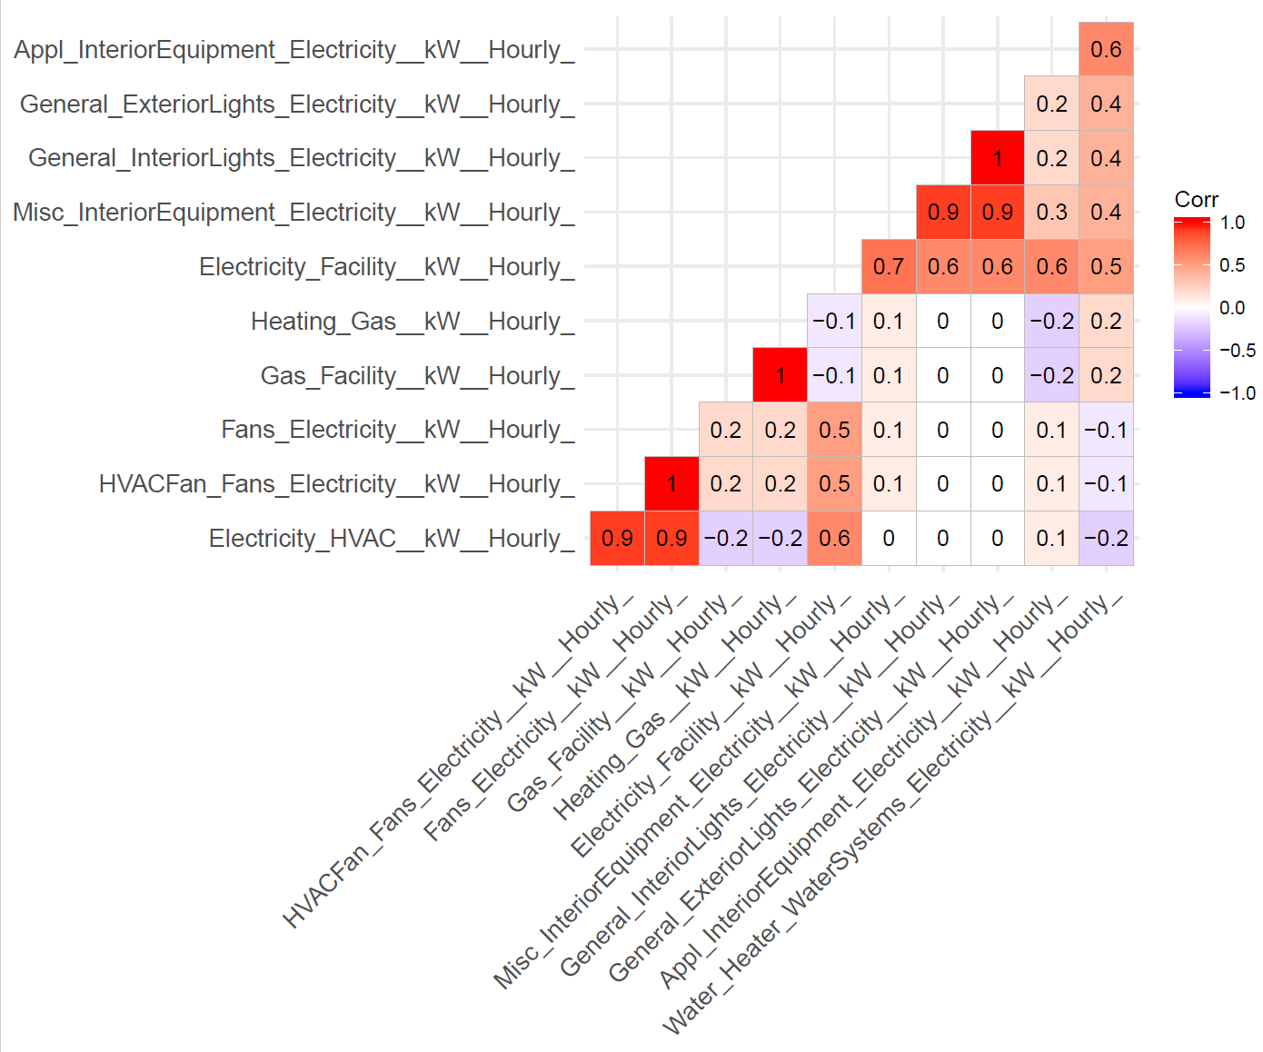

* The highest correlation between the measurements is between HVACFan_Fans_Electricity__kW__Hourly_ and Fans_Electricity__kW__Hourly_ , Electricity_HVAC__kW__Hourly_ and HVACFan_Fans_Electricity__kW__Hourly_. This indicates there is a strong linear relation between them.
* The lowest correlation between the measurements occurs between General_ExteriorLights_Electricity__kW__Hourly_ and Electricity_HVAC__kW__Hourly_ which shows there is no relationship between them.